Airport Management System

Group Member Names:

* Fakeha Tariq (Cluster Head)
* Ruba Abid
* Tamkeen Ahmed
* Syed Nauman Ahmed Shah
* Elsa Asif
* Aaima Arshad
* Hafsah Azmat
* Aneela Karim
* Muhammad Ali

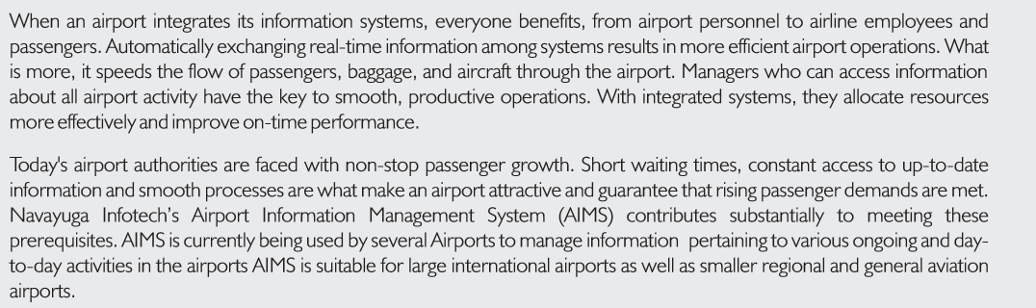**Project Description**

**[Airport Management System]**